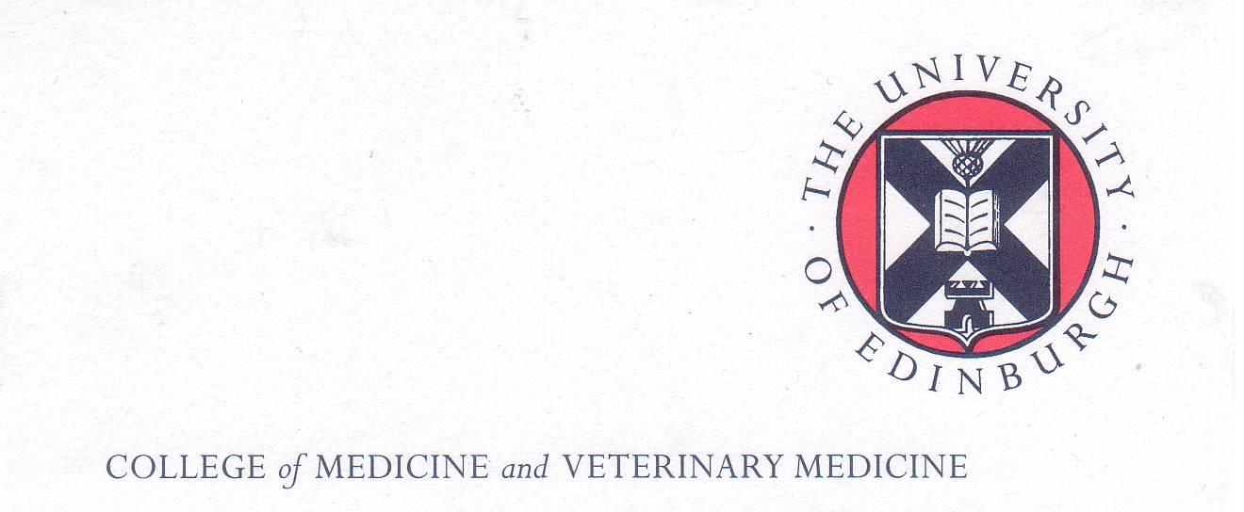
The Boloz-Kulesza Trust Fund and
Polish School of Medicine Memorial Fund
Scholarship Programmes 2018/2019

Call for Scholarship Applications
Edinburgh Winter Stroke School 18th-20th February 2019

Introduction
The Bóloz-Kulesza Trust Fund and the Polish School of Medicine Memorial Fund support thriving scholarship programmes which enable successful applicants to undertake a period of further study or research at The University of Edinburgh Medical School and related institutions.

The Course: The 3 day winter stroke school run by experts in the field is highly popular and feedback from previous participants is very positive. Places on the course will be limited. For further information on the course go to:

https://www.ed.ac.uk/clinical-brain-sciences/postgraduate-training/edinburgh-stroke-winter-school

The Scholarship: A total of 4 scholarships will be available. Each scholarship will cover the cost of: The course fee and catering for all 3 days and the course dinner (£250), 4 nights’ accommodation on a bed & breakfast basis at Pollock Halls of Residence ( ie from Sunday 17th February to the morning of Thursday 21st February 2019). The scholarship does not cover travel to and from Poland.

Eligibility
These scholarships are open to Polish medical scientists /neurologists working in stroke research who are:
- in their early career (usually within 10 years of their medical graduation - MB ChB equivalent)
- working in Polish Medical Academies/Universities and Research Institutes
- committed to the further development of expertise in the field of clinical neurology in Poland and
- have excellent mastery of English .

Successful applicants are:
- expected to meet the general criteria for the award of these scholarships;
- attend the full course, not arrive late and/or depart early;
- submit a short report of their experience on the course by e-mail to the Scholarships Coordinator within one month of its completion

Note: The expectation and intention of the founders of both The Polish School of Medicine Memorial Fund and the Boloz-Kulesza Trust Fund Scholarship Programmes are that successful applicants will return to their units/ departments in Poland on completion of their attachment/studies, use their new found skills to further enhance and develop Polish medicine including medical research and thus foster academic links between Polish Medical Universities and Research Institutes and The University of Edinburgh.

Please note: There is a separate application process for the course itself and applicants should check the course web site (see above) to ensure they meet the closing date for course applications

Closing date for scholarship applications: 17.00hrs Friday 14th December 2018.
Late applications will not be considered

How to Apply

1. Applications should be sent electronically to the Scholarship Coordinator, Dr Maria Dlugolecka-Graham MBE (e-mail:maria.graham@ed.ac.uk) by the closing date (14th December 2018). Late applications will NOT be considered

2. Applicants must submit the following documents in support of their application:

- An up- to-date CV giving adequate information about their expertise and training in clinical neurology to date. A list of dates and posts held will not suffice;

- A letter of support from their Rektor or vice- rector;

- Documentary evidence of having an adequate mastery of English. Where no externally validated certificate ( eg IELTS, TOEFL or Cambridge Advanced or Proficiency Certificate or equivalent is available, applicants will be required to undergo a Skype or telephone interview to establish the level of their English language skills Applicants must indicate that they agree to this assessment in their scholarship application..

- A statement ( of no more than 500 words) of why they wish to be considered for a scholarship and how they personally and their department are likely to benefit from their participation in the course

- A signed statement in which they agree to write a short report of their experience on the course and submit it by e-mail to the scholarship coordinator within 1 month of completing the course.

Note: A template for preparing the report is available but the scholars are not obliged to use it.

Closing date for applications: 17.00hrs Friday 14th December 2018

For enquiries about applying for these scholarships, please contact:

Dr Maria Dlugolecka-Graham MBE
Polish School of Medicine Coordinator for The University of Edinburgh
College of Medicine & Veterinary Medicine The University of Edinburgh,
Room SU205, Chancellors Building
49 Little France Crescent
Edinburgh EH16 4SB UK

e-mail: maria.graham@ed.ac.uk

